January 11, 2018- The Catholic Watchmen- St. John the Baptist Catholic Church
Bishop Andrew Cozzens- Fully Engage in every Sunday Mass
-Quote from St. Justin Martyr from 155ad about the Mass showing the Mass has not changed
-If we understand what’s happening then we can engage and appreciate the Mass as God desires us to
-The Mass contains Jesus and his life giving death on the cross
-Jesus’ last command was to celebrate the Mass- “Do this in memory of me.”
-The last supper, the death of Christ and resurrected presence of Christ becomes present at the Mass
-Need to celebrate with reverence this special moment
-CCC 1085-When Jesus says the words of the institution, it really happens because Jesus is God and his word is true
-Transubstantiation- the bread and wine really change in their substance even though their appearances don’t change
-There is no more bread and wine, rather the body, blood, soul and divinity of Jesus is there
-John 6 speaks about the real presence of Jesus in the Eucharist
-Jesus’ saving death becomes present at every Mass
-We become present to that moment in time when Jesus surrendered everything on our behalf
-We come to Mass to join in Jesus’ sacrifice and receive forgiveness and strength
-God gives Jesus back to us even though we offer him to God
-There is true power that happens at Mass
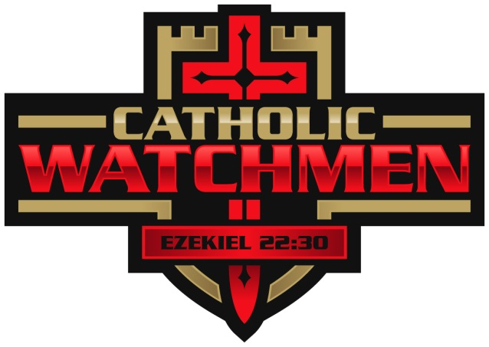
-People have risked their lives to receive the Eucharist because they knew the power of the Eucharist
-We need grace in order live charity in the world

  - How has the last month been?
  - What was one thing your learned from the video?
  - How do you get the most out of Mass every Sunday? How do you prepare for Mass?

