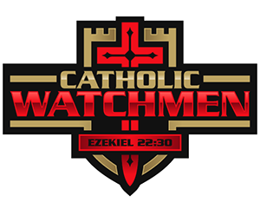
Catholicism 101- Some Basics of our Catholic Faith- July 13, 2017
Presentation by Fr. Paul Shovelain and Dominic Shovelain
The Trinity- we are made in God’s image
- “Let us make man in our image.” Genesis 1:26
- We are made for relationship and communion with others and ultimately God
- That end goal is Heaven
- Created by the Trinity to share in their goodness
- Sin enters and divides God and humans, man and woman, and within one’ s self
- Christ comes to bridge the gap and unite God and Man
- The Church is the presence of Christ here on Earth and now the Church bridges the gap
- Called to live in Communion with God through living in communion with Christ in the Church
Faith –Gift that unites us to God
- Bridges us to Christ and his Church, in turn restoring relationship to the Father
- Is belief in God and all that He has said and revealed to us, and what Holy Church Proposes
- Faith is not Blind
- Is trusting in God, similar trusting in other people when they share themselves
- Is Certain. God is Truth itself, Jn 14:6
- Is a Grace. Gift of God, infused in the Soul. Peter, “You are the Christ.” Mt 16
- Restoring relationships:
-Trust in the Father
-Dignity of each person
-Sonship of oneself. Lessening of Pride manifest in self-reliance
Saints- Examples of Men and Women who lived in communion with God through Faith
- St. Joseph
  - Father of Jesus and Husband of Mary- hard living with two perfect people!
  - Man who responds to God’s will right away
  - Trusts in God even in uncertainly
  - Known as a just man who was chosen by God
  - Patron saint of workers as he taught Jesus how to work
- St. Hubert
  - Patron saint of hunters
  - Married and then widowed
  - Became a religious and then a bishop
  - He was noted for his miracles and for converting hundreds.
- St. John Paul II
  - Lost his mother as a boy, then his brother and then his father
  - Trusted in God the Father as his family
  - Used his gifts for God and brought joy to many people
  - Fulfilled through using his gifts and fulfilled others in doing so
  - Known for his courage and charming personality
  - Key to breaking down communism as he focused on the dignity of every human person
- Next Meeting Bonfire at Steve Arndofer’s House- 1210 Holly Drive E, Lino Lakes, 6:30 PM August 17

