May 17, 2018- The Catholic Watchmen- St. John the Baptist Catholic Church
-The Fatherhood of God
- Jesus came to reveal God as Father, calls God “Our Father”
-This was a crazy idea, Jews didn’t think they could have that familiarity with God, didn’t see God as personal before
-In the Sermon on the Mount Jesus calls God “Father” 17 times
-God’s Fatherhood is the deepest mystery of his identity, John 1:14 see God’s Fatherhood revealed right away, He adopts us as his children through Christ Gal 4:4-7
-Note as well that we have the SAME Father
-John 20:17, I am ascending to my Father and your Father
-Father sent the Son as Savior of the World! 1 John 4:14
-Scandalized the Jews because it was so personal
-Scripture References to the Father
-Called to obey him and do his will
-Father gave him free will just like he did us
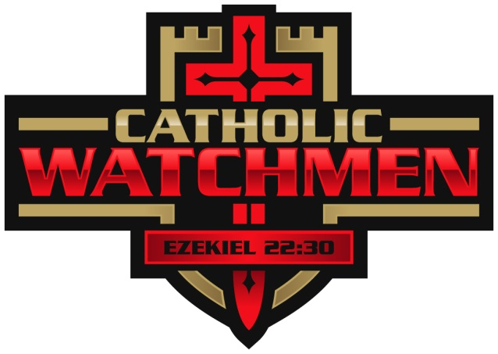
- Nature of God the Father
Father- what is the nature of a Father? It is to give life. As men we are Fathers, we are life givers. Sign of the Cross- Hand comes down from above, God provides, he gives us life
-Threefold mission of a Father- Provide, Protect, Establish
Provide- food, shelter, love
Protect- Guard, preserve
Establish- Affirm, support
-Called to provide- for spiritual, emotional and physical needs
-Called to protect them from danger and from sin
-Called to establish them in confidence and love

Questions for Discussion
  - How has the last month been?
  - What was one thing you learned from the Talk?
  - What is your attitude toward confession?

