Welcome to FallFest Silent Auction! This page can help you be sure you have a valid bidding account. Let's get you signed in and ready to help raise some money for St. John the Baptist!
Do you already have an account? The answer is YES if...
- you purchased any kind of ticket through your group's Silent Auction Pro™ ticket page for Wines to Wishes
- you received an email or text message indicating you are "approved for online bidding"
- you received a Welcome message via text, specifying your bidder number/status
- you have logged into Silent Auction Pro™ as a bidder at Wines to Wishes or FallFest 2020
If you think you might have an online bidding account with Silent Auction Pro, try using the I forgot my username/password link to retrieve your credentials.
If you do not have an online bidding account, start here!
- Go to the Silent Auction Pro™ web site.
  - If you are on your phone or mobile device, click here.
If you access Silent Auction Pro from your phone with the desktop/laptop link, your phone will ask if you want to switch to Silent Auction Pro Mobile? Click OK. These directions are optimized for users bidding on a mobile device.
- Enter the Group Number 220 into the Group Number field, and then click the Log In or Register button.
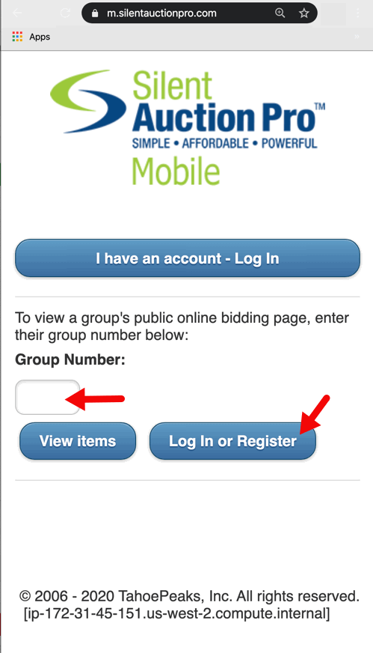
- Click the I don't have an account button.
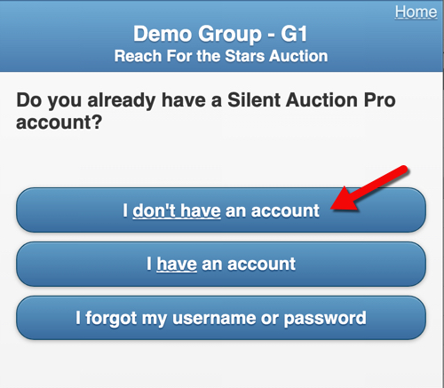

- On the Create an Account page - Step 1 page: Create a Username and Password. You are welcome to use your email address as your username or make one up of your choosing. Passwords must be 8 to 16 characters long and contain at least 1 upper case character, 1 lower case character and 1 number. Passwords may contain the following special characters: !$@=/#&~+ but may not contain spaces.
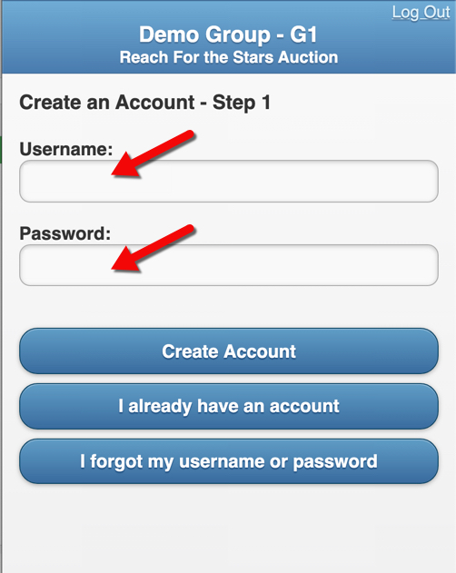
- On the User Information page - Step 2 page: Enter your personal information. Click the Create Account button. Your First Name, Last Name and Email are required. If you chose to omit your cell phone number from the User Information page, you will NOT receive text message notification messages when you are either out bid, or have won an item. Please consider sharing your cell phone number to help you stay informed and involved with your auction. Silent Auction Pro will never sell or give your personal information to anyone not associated with the organization or organizations for which you are using our system. Texts can only be received if you Opt In for text messages originating from Silent Auction Pro™ short code number: 63665.
Click here for more information on text message Opt In options and information.
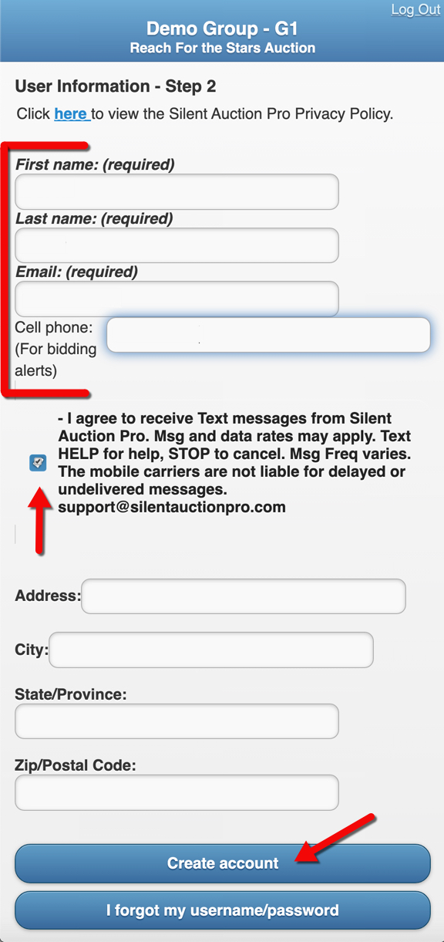
- On the Register for Online Bidding page: Select your credit card type from the blue Select One button. Note: only credit cards can be used. No debit cards.

- Click the Next button to advance to the next page where you will confirm your user information.
Click the Next button again.
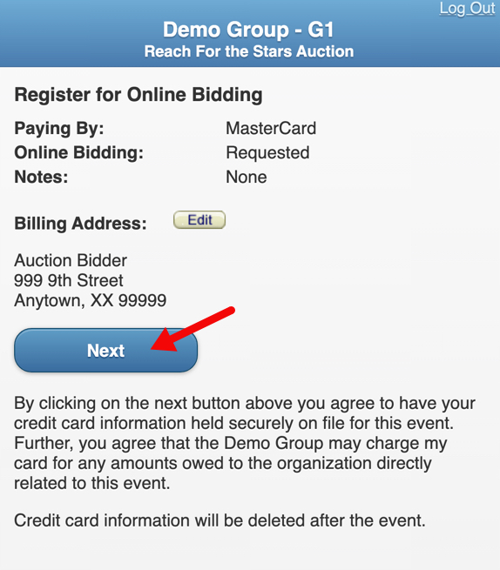
- Enter your credit card number and expiration date. Click the Process Card button. The screen refreshes with your Payment Record for a $0 authorization of your card.
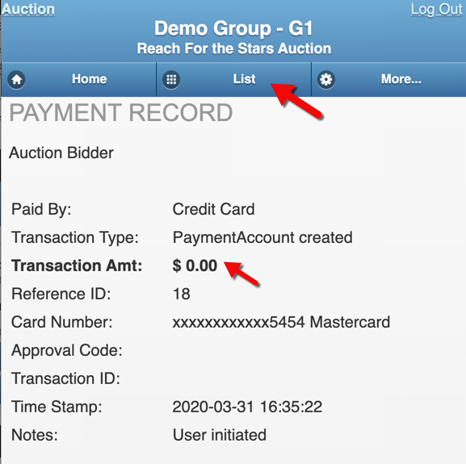
You are now ready to bid!
Your credit card number is held securely on file by a fully PCI compliant card processor of your group's choosing (Worldpay).
- Click the List button in the blue navigation bar near the top of the screen. Now, you can click to view All Items, or choose one of the filter options for item viewing.
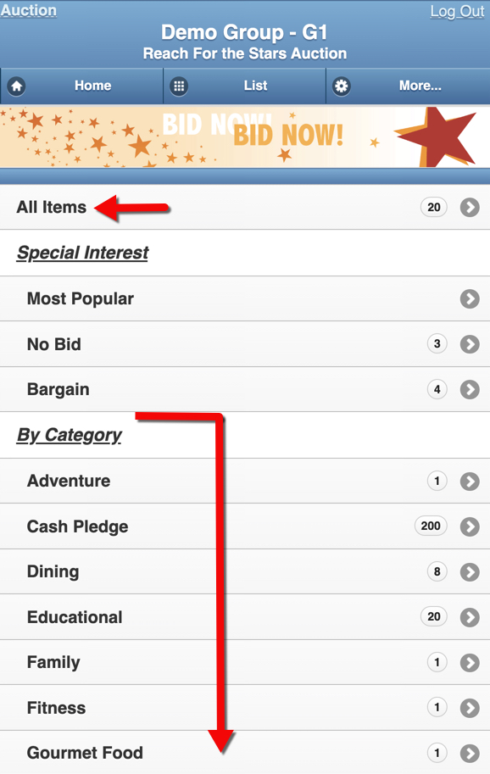
If you are having trouble with any part of the account creation, login, or bidding process, please contact Silent Auction Pro™ tech support via email or by phone: 408-583-4880 x2.
Ready to Bid!
Now that you've created an active bidding account, you're ready to bid! Touch the item in which you're interested, and the item detail page displays.
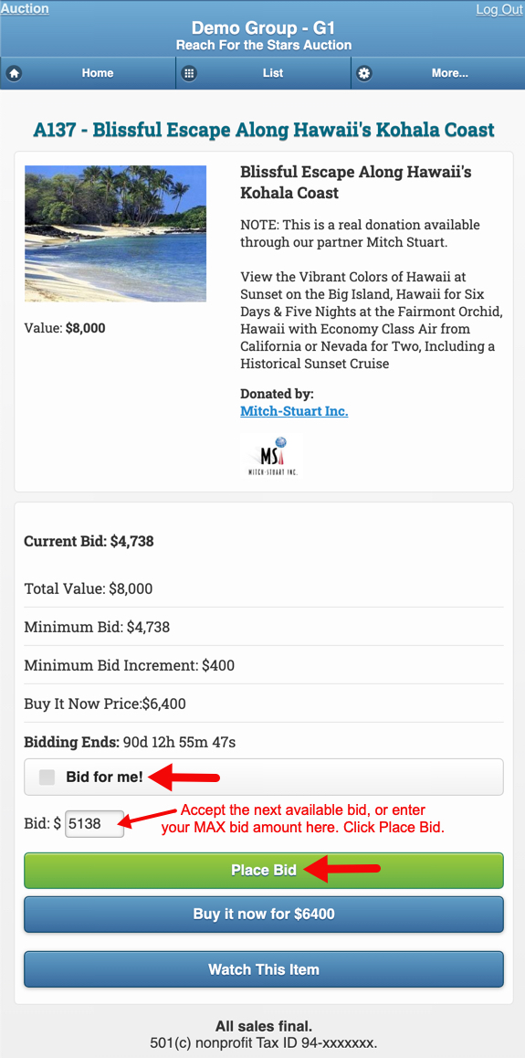
The software will display the next valid bid available for this item. You can click the green Place Bid button to record your bid on this item.
Once you place your bid, you are the winner of that item until someone out bids you. If another bidder places a bid higher than yours, you will receive a notification via text message letting you know that your bid is no longer the highest bid.
Alternatively, you can allow the software to bid on your behalf, up to your maximum allowed bid. Enter your max bid amount in the Bid $ field, and then click the Bid for me! check box.
You will not receive out bid notifications for an item on which you are using the Bid for me! option.
Another bidding option is:
- Watch This Item: Click the Watch This Item button to flag this item on your Bidding Status page, making it easier for you to keep an eye on the bidding.
Time to Checkout
When bidding has ended, it's time to check out and pay for your items or make an additional donation.
If you are the winner of one or more items, you will receive both an email and text message notification indicating which items you have won.
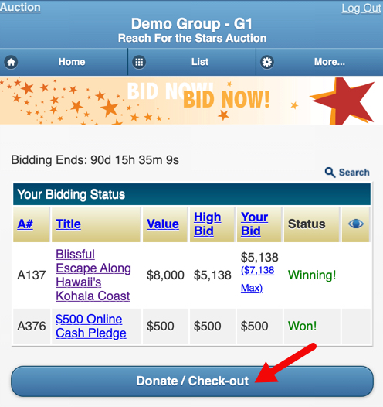
Even if you did not win an item, consider making a cash donation to St. John the Baptist. Click the Donate / Check Out button and enter a cash donation amount in the Additional Donation field toward the bottom of your invoice.
After you receive notification that you have won, go back to your Silent Auction Pro home page, and click the Donate / Check Out button.
Review your invoice, consider adding an additional donation, and then pay with the card on file, or choose to add a new credit card. Click the Process Payment button to complete your checkout.
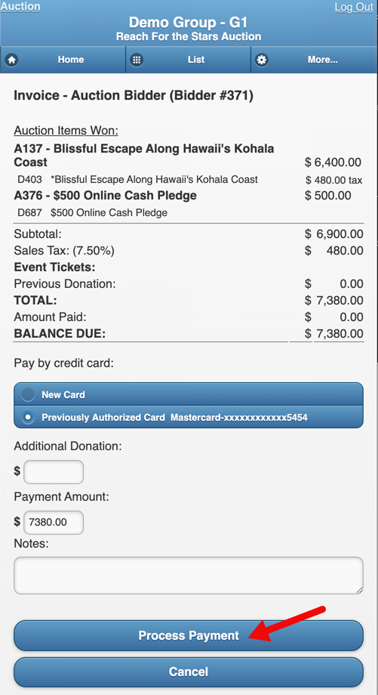
Once your payment has processed, the screen refreshes with a Payment Record. You will also receive a receipt via email.
If you need help...
We are here to help! If you are having trouble with any part of the account creation, login, or bidding process, please contact Silent Auction Pro™ tech support via email or by phone: 408-583-4880 x2.
Happy Bidding, and thank you for supporting St. John the Baptist!

