Middle School Faith Formation 2022-2023
Middle School Faith Formation is a program for families with youth in grades 6, 7 and 8 which meets weekly on Wednesday evenings from 6:00-7:30pm in the Youth Room September to May. Students build community with large group prayer and engaging activity and a competition between the Northern Kingdom and the Southern Kingdom. The program introduces youth to the bible and prepares them for discipleship in Christ. The program also incorporates family discipleship by parents participating in the Parent Program once a month in conjunction with parents in Family Formation. These nights are intentionally family friendly with confession at 5:00pm (childcare is provided). Dinner at 5:30pm. Middle School and Family Faith beginning at 6:00pm. On Family Formation nights, Middle Schoolers will participate with any family discipleship elements. Students who come without parents on these nights will join Sarah and the middle school core team. These nights are indicated on this schedule with an +.

September 21+ Kick Off with Family Formation – Parent Program
28
October 5+ Parent Program
12
19 No session over MEA
26 All Saints Day Mass, dinner and games.
Middle School will run the games
November 2
9+ Parent Program
16
23 No Session due to Thanksgiving
30
December 7+ Parent Program
14
21 & 28 No Session due to Christmas Break
January 4 No Session due to Christmas Break/Catechist Inservice
11+ Parent Program
18
25
February 1+ Parent Program
8
15
22 No Session but attend Ash Wednesday Mass as a Family
March 1+ Parent Program
8
15 No Session due to Spring Break
22
29
April 5 No Session due to Holy Week but attend Holy Week Services as a Family
12+ Parent Program
19
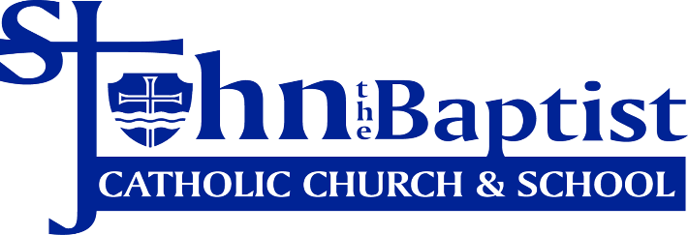
26
May 3+ Parent Program

Sarah Wilder
Coordinator of Middle School and Young Adults
wilders@stjohnnyb.org 651.633.1540 ext.1254

