Middle School Formation 2023-2024
Middle School Formation is a program for families with youth in grades 6, 7 and 8 which meets on Wednesday evenings from 6:00-7:30pm. Through our weekly Wednesday Night Bible Study students build community, encounter God’s Word, engage in large group and small group prayer, and compete for the Kingdom Cup. The program introduces youth to the bible and prepares them for discipleship in Christ. The program also incorporates family discipleship by providing a Parent Program once per month in conjunction with our Family Formation program (families with children K-5). These nights are intentionally family friendly with dinner at 5:30pm, programs for parents, middle schoolers, children K-5th and childcare for younger children.

September 20+ Kick Off with Family Formation – Parent Program – Meet in Church
27
October 4+ Dinner @ 5:30 and Parent Program
11
18
25 All Saints Day Party— Middle School students are invited to attend with their families or volunteer to run games.
November 1+ Holy Day Mass 5:30, Dinner 6:00, and Parent Program 6:30
8
15
22 No Session due to Thanksgiving
29
December 6+ Dinner @ 5:30 and Parent Program
13
20
27 No Session due to Christmas Break
January 3 No Session due to Christmas Break/Catechist Inservice
10+ Dinner @ 5:30 and Parent Program
17
24
31
February 7₊ Dinner @ 5:30 and Parent Program
14 Ash Wednesday Mass @ 5:30 followed by MS Formation
21
28
March 6+ Dinner @ 5:30 and Parent Program
13 No Session due to Spring Break
20
27 No Session due to Holy Week but attend Holy Week Servies as a Family
April 3+ Dinner @ 5:30 and Parent Program
10
17
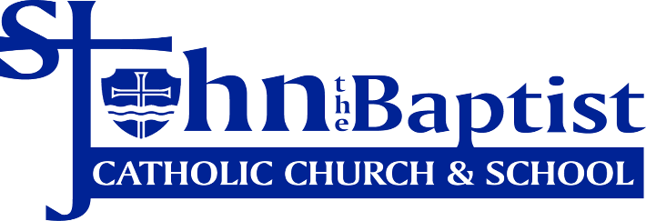
24
May 1+ Dinner @ 5:30 and Parent Program

Sarah Wilder
Coordinator of Discipleship for Middle School Youth
wilders@stjohnnyb.org 651.633.1540 ext.1254

